Data Management for Decision Support for Cotton Producers in the Rio Grande Valley.
Version 1.2
Document Control
Approval
The Guidance Team and the customer shall approve this document.
Document Change Control
Initial Release: | 6/9/03
Current Release: | Version 1.2
Indicator of Last Page in Document: | §
Date of Last Review: | 08/25/03
Date of Next Review: | TBD
Target Date for Next Update: | 10/01/03
Distribution List
This following list of people shall receive a copy of this document every time a new version of this document becomes available:
Guidance Team Members:
Dr. Steve Roach
Dr. Ann Gates
Monica Miranda
Client: Dr. Joe Ellington
Dr. Jeff Drake
Dr. Denise McWilliams
Mr. Tracey Carrillo
Software Team Members:
Cyber Mantis
Digital Insects
Pupas
Software Engineering Solutions Corporation
Change Summary
The following table details changes made between versions of this document

Version | Date | Modifier | Description
0.01 | 06/9/03 | M. Miranda | Modified all the paragraphs.
0.02 | 07/01/03 | M. Miranda | Combined requirements section for Software Teams SRSs
0.02 | 07/9/03 | M. Miranda | Use Cases, Relational DB Diagram, Object Model
0.03 | 07/19/03 | S. Roach | Reviewed section 3
0.04 |  | M.Miranda/S. Roach | Updated Sections 1 and 2
0.05 |  | M.Miranda | Modifications Section 3
0.06 | 07/31/03 | M.Miranda | Combined Dr. Roach’s Sections 1 and 2 with Section 3
0.07 | 08/02/03 | M.Miranda | Security Protocol and Menus
0.08 | 08/07/03 | M. Miranda | Section 3 Review and Modifications
0.09 | 08/12/03 | M. Miranda | Changes to Section 3
1.0 | 08/14/03 | M. Miranda/S. Roach | Final review changes before client’s approval
1.1 | 08/15/03 | M.Miranda/S.Roach | Corrections after validation by clients
1.2 |  | M. Miranda/S. Roach | Corrections by class, administrator functions
Table of Contents
Document Control ii
Approval ii
Document Change Control ii
Distribution List ii
Change Summary ii
1. Introduction 5
1.1 Purpose and Intended Audience 5
1.2 Scope of Product 5
1.3 Definitions, Acronyms, and Abbreviations 5
1.3.1 Definitions 5
1.3.2 Acronyms 8
1.3.3 Abbreviations 9
1.3.4 Overview 9
1.4 References 10
2. General Description 12
2.1 Product Perspective 14
2.2 Product Features 14
2.2.1 Use Cases 15
Use Case 1: Log In/Out 15
Use Case 2: Run External Program 17
Use Case 3: Manage Data 18
Use Case 4: Query/Output Data 22
Use Case 5: Archive Data 23
2.3 User Characteristics 24
2.4 General Constraints 25
2.5 Assumptions and Dependencies 25
3. Specific Requirements 26
3.1 External Interface Requirements 26
3.1.1 General Characteristics 26
3.1.2 Menu Options 26
3.1.3 Display Screen and Windows 26
3.1.3.1 Common Screens and Windows 27
3.1.3.2 Data Entry Users 27
3.1.3.3 Data Administrators 27
3.1.4 Hardware Interfaces 27
3.1.5 Software Interfaces 27
3.1.6 Communications Interfaces 28
3.2 Behavioral Requirements 28
3.2.1 Same Class of User 28
3.2.1.1 Data Entry User 28
3.2.1.2 Data Administrator 29
3.2.2 Related Real-world Objects 29
3.2.2.1 External Programs 29
3.2.2.2 Fields 29
3.2.2.3 Season 29
3.2.2.4 Plants 29
3.2.2.5 Insects 29
3.2.3 Stimulus 30
3.2.3.1 Login 30
3.2.3.2 Menu Item Selected 30
3.2.4 Functional 33
3.2.4.1 Queries 33
3.2.4.2 Query Results 33
3.2.4.3 File Relations 33
3.2.4.4 Export/Download 33
3.3 Non-behavioral Requirements 34
3.3.1 Performance Requirements 34
3.3.2 Qualitative Requirements 34
3.3.2.1 Availability 34
3.3.2.2 Security 34
3.3.2.3 Maintainability 34
3.3.2.4 Portability 35
3.3.3 Design and Implementation Constraints 35
3.4 Other Requirements 35
3.4.1 Database 35
3.4.2 Operations 35
3.4.3 Site Adaptation 35
4. Appendix A Data Flow Diagram 36
5. Appendix B Message Sequence Diagrams 37
6. Appendix C Relational Database 38
7. Appendix D: Client-Server Architecture 42
8. Appendix E Security Protocol 43
9. Appendix F Predefined Queries 44

List of Tables
Table 1 Definitions 8
Table 2 Acronyms 9
Table 3 Abbreviations 9
Table 4 Actors 24
Table 5 External Programs 25
Table 6 Menu Options 26
Table 7 Security Protocol 43
List of Figures
Figure 1 Field Layout 13
Figure 2 Use Case Diagram 14
Figure 3 Grid Display 19
Figure 4 User Interface Layout 27
Figure 5 File Selection 30
Figure 6 Query Dialog Box 34
Figure 7 Data Flow Diagram 36
Figure 8 Import Sequence Diagram 37
Figure 9 Database Decomposition 40

Introduction

Purpose and Intended Audience
The purpose of this Software Requirements Specification (SRS) is to clearly and accurately portray the requirements of the software system being developed, hereafter referred to as the Data Management for Decision Support for Cotton Producers in the Rio Grande Valley, the Cotton Data Management System (CDMS), or simply the System. The developers will use this document to identify the product features, product perspectives, user characteristics, the system’s constraints and dependencies, and external interface, behavioral, non-behavioral, and other types of requirements. Behavioral requirements describe the interaction between the system and its environment. Non-behavioral requirements relate to the definition of the attributes of the product as it performs its functions. The intended audience for this document is Dr. Joe Ellington, Dr. Jeff Drake and Dr. McWilliams, the Guidance Team, and the software development teams. It will be used as a reference in the design, implementation, and maintenance of the software. The SRS serves as an agreement between the abovementioned parties regarding the software that will be developed.

Scope of Product
Cotton producers in the Rio Grande valley of New Mexico need to quickly adapt to new growing restrictions and conditions. One possible adaptation is to switch to organic production. Organic production can reduce expenses, improve cotton price and marketing opportunities, and reduce the environmental impact associated with the application of broad-spectrum insecticides. Organic cotton production requires alternative approaches to the control of insect pests. Dr. Joe Ellington and Dr. Jeff Drake of the Department of Entomology at New Mexico State University (NMSU) in Las Cruces, New Mexico have been working to develop biological controls of insect pests. They are working to develop a decision support system (DSS) that will accept data from a variety of sources and assist producers in the management of their cotton crops. This decision support system requires a sophisticated data management system to collect and store data in an appropriately structured way to avoid redundancy and to ensure data integrity. Information required by the DSS includes weather history, irrigation and pesticide application history, agronomic data, insect population data, and data from graphical information systems (GIS). The system described in this document is the data management software, CDMS.

Definitions, Acronyms, and Abbreviations

Definitions
Table 1 below lists the definitions used in this document with respect to the CDMS. The definitions given below are specific to this document and may not be identical to definitions of these terms in common use. The purpose of this section is to assist the user in understanding the requirements for the system.

TERM | DEFINITION
Alter | SQL command to change the structure of a table, used here as a means of renaming, adding, or removing columns
Attribute | - A quality or characteristic of an item  - A column of a database table
Backup database | To create a copy of database data for error recovery purposes
Block | A subdivision of a cotton field
Boll | The seed and lint bearing pod or capsule of the cotton plant
Boll count | Count of bolls on one cotton plant; collected for COTMAN
Browse | To causally search for information
COTMAN | A software program that uses cotton crop monitoring techniques and weather data to predict crop yields and assist cotton growers with management decisions
Database Management System | A software system that enables users to define, create, maintain, and control access to a database
Decision Support System | An interactive computer based program that help managers make decisions by retrieving, summarizing and analyzing data that is relevant to the decisions
Dialog Box | A special type of window used to exchange information with the system. Most dialog boxes provide an OK button and a Cancel Button.
Drop | An SQL command used to delete an entire database table with its resultant data
Excel | A spreadsheet program by Microsoft Software included in the Office software bundle
External program | Any program with which our system will interface
Field | - A plot of ground set aside for crops  - In a database, an attribute (column) of a data; the smallest structure in a relational database that stores individual pieces of data about an entity
First fruiting node | The average first sympodial branch on 10 plants at four locations in a field; collected for COTMAN once per season
Foreign Key | A field in a relational data base that is used to link relations between the tables that is a primary key from another table
Fruiting node | The point on a stem where a leaf is attached or has been attached
GIS coverage | A table linked to graphic information
Grower | The person who grows or produces cotton
Handheld device | An electronic data recorder for COTMAN; may also be used for input to CDMS
Hyperlink | A segment of text or a graphical item that serves as a cross-reference between parts of a the system
Image data | Image files and identification information for image files
Image File Directory | A directory of all image files contained in the system
Image Processing System | Programs currently in use by our clients that automatically count and classify insects through image processing
Infrared reflectance | A measure of stress on plants; usually measured by processing an over flight image of a field
Insect density | Measure of insect population per unit area in a field
Latitude | Angular distance north or south from the earth’s equator measured through 90 degrees
Links | See hyperlink
Login | The process of gaining access to certain features of the Cotton Data Management System
Longitude | Angular distance measured on a great circle of reference from the intersection of the adopted zero meridian with this reference circle to the similar intersection of the meridian passing through the object
MatLab | A mathematical software application that may be used by the CDMS for statistical analysis
Message Box | A graphical user interface object used to display warnings when an incorrect action has occurred or when more information is required from the user
Nodes above white flower | Number of nodes above a cotton plant’s white flower; collected once per week for COTMAN
Plant height | Height of cotton plant; collected once per week for COTMAN
Post condition | Conditions that must be true when a procedure is completed
Primary Key | A field that is selected as being most important for identifying a record in a table, it will have a unique value in the table
Precondition | Conditions that must be true prior to beginning a procedure
Predator/prey ratio | Ratio of predator insects to prey insects; essential in determining whether a field is in a state of biological control
Producer | See grower
Query | The process of requesting information from the system
Record | In a database, a unique row in a table; a set of fields that describe a single occurrence of some entity described by the table
Relational database | A structured collection of data. The data is stored in two or more tables that enable you to define relationships between the tables. The link between the tables is based on one or more field values common to both tables. see primary and foreign key
Scenarios | A sequence of steps describing the interactions between a user and a system, part of a use case
Server | A computer that provides services to other computers (Clients)
Soil moisture | Measure of moisture in soil, collected through tensiometer or moisture element readings
Square counts | Count of squares (buds) on a cotton plant; collected once per week for COTMAN
Stand density | The average number of cotton plants in 3 row feet in a field
Stand Density | The number of plants per square foot
Structured Query Language | The standard language for relational database management systems. SQL statements are used to perform tasks such as update data on a database, or retrieve data from a database.
Table | A table is a collection of data about a specific topic. A set of rows and columns. These sets do not have any predefined sort order for the elements. Each row(record) is a set of columns (table fields) with only one value for each. All rows from the same table have the same set of columns.
Text data | Data that may be displayed in a table, including measurements
Trigger condition | An action causing the automatic request of a procedure. A trigger happens when the user wants to modify data either by the insert, delete, or update command. A trigger notifies the system to take some action when a specified change is attempted
Update | The process of modifying existing data
Use Case | Abstractions of the important operations that provide value to a user. They describes the interactions between an actor and the system.
Use cases diagrams | A diagram that represents the external entities that interact with the system and the principal uses of the system
Vector overlay maps | Maps that use GIS data to create a graphical representation of one type of data
View | A virtual table derived from base tables that permit users to access data in a way that is customized to their needs
Yield | Amount and quality of cotton produced by a field
Public key/Private key Encryption | Encryption that involves a pair of keys--a public key and a private key. These keys are used to authenticate and entity electronically or to sign or encrypt data. Each public key must be published and know by everyone who requests it, and the corresponding private key is kept secret. Data encrypted with your public key can be decrypted only with your private key.
Needham-Schroeder | A public key authentication protocol that provides mutual authentication between an initiator agent A and a responder agent B, both of which want to be assured of the others' identity before starting a communication session
Table 1 Definitions

Acronyms
ACRONYMS | MEANING
ASCII | American Standard Code for Information Interchange
CDMS | Cotton Data Management System
CSV | Comma Separated Variable
DBMS | Database Management System
ESC | Escape
GIF | Graphic Interchange Format
GIS | Geographic Information System
GPS | Global Positioning System
GUI | Graphical User Interface
IPS | Image Processing System
JPG or JPEG | Joint Photographic Experts Group (Image Format)
NMSU | New Mexico State University
PACES | Pan American Center for Earth and Environmental Studies
PDA | Personal Digital Assistant
SQL | Structured Query Language
SRS | Software Requirements Specification
TIFF | Target Image File Format
UTEP | University of Texas at El Paso
Table 2 Acronyms

Abbreviations
ABBREVIATION | MEANING
avg. | Average
e.g. | For example.
et al. | And others.
i.e. | In other words
no. | Number
sat. | Satellite
sq ft. | Square feet
Table 3 Abbreviations

Overview
This section describes the overview of the CDMS requirements. The SRS is divided into 3 major sections: Introduction, General Description, and Specific Requirements. The Introduction describes the primary audience, the purpose of the CDMS, and provides definitions, acronyms, abbreviations and references to assist the reader of this document. The General Description contains details of the product, its functionality and its structure. It contains:
    - Product perspective provides a brief description of the product and also gives a perspective of the CDMS in relation to other products if any.
    - Product features gives a description of the main features of the product.
    - User Characteristics gives a description of the users of the CDMS as well as the capabilities of the different types of users.
    - General Constraints includes hardware limitations, safety and security considerations, and any other known constraints.
    - Assumptions and Dependencies, state the factors that have an affect on the SRS requirements. The Specific Requirements section states provisions that various aspects of the system will have in order to fulfill the needs of the customer.
    - External Interface Requirements lists the requirements of the user interface, hardware interface, software interface, and communications interface.
    - Behavioral Requirements, requirements that define the CDMS operations.
    - Non-Behavioral Requirements are requirements that define the characteristics of the CDMS during its operations.
    - Other Requirements, contains a list of database, operations, and site adaptation

The Specific Requirements section describes the specific requirements for the software system. It consists of
- External Interface Requirements, which describes the requirements for user, hardware, software, and communications interfaces;
- Behavioral Requirements, which divides behavioral requirements into the following categories: related real-world objects, stimulus, related features, and functional requirements;
- Non-Behavioral Requirements, which includes performance requirements, qualitative requirements, and design and implementation constraints; and
- Other Requirements, which will list all other requirements not included in the previous sections.

Appendix A contains the data flow diagram for the system.
Appendix B contains the message sequence diagram for the import data process.
Appendix C contains the relational diagram that describes the database decomposition of the system.
Appendix D contains the diagram and description of the Client-Server architecture fore the system.
Appendix E describes the security protocol that will be needed for the system.
Appendix F list some predefined queries that the system will have.

References
[1] Roach, Steve. “Requirements Definition: Data Management for Decision Support for Cotton Producers in the Rio Grande Valley.” Jan 2003.
[2] Drake, Jeff, Joe Ellington, and Denise McWilliams. Personal Interview. 31 Jan 2003.
[3] Drake, Jeff. “Requirements.” 31 Jan 2003.
[4] Drake, Jeff. “Re: Undecided Issues from Team 2.” E-mail to SESC. 25 Mar 2003.
[5] Ellington, Joe. “Project Timetable: Data Requirements for Each Year”. 31 Jan 2003.
[7] SESC. Interview Report 1. 31 Jan 2003.
[8] SESC. Interview Report 2. 10 Feb 2003.
[9] SESC. Prototype Manual. 28 Mar 2003.
[10] University of Arkansas Division of Agriculture. “COTMAN: Cotton Management Expert System Software”. http://www.uark.edu/depts/COTMAN/. 31 Jan 2003.
[11] Texas A & M Agriculture News, “History of Cotton Farming in Lower Rio Grande Valley of Texas”, [Online Document], 2001 April 16, Available HTTP: http://twri.tamu.edu/watertalk/archive/2001-Apr/Apr-16.3.html,
[11] D. Gollmann, Computer Security, John Wiley & Sons, Inc., 1999.
[12] “Oracle9i database, [online site] Copyright © 2003, Oracle Corporation, http://www.oracle.com/ip/deploy/database/oracle9i/
[13] Y. Shohound, Real World XML Web Services for VB and VB.Net Developers, Addison Wesley, Pearson Education, 2003
[14] Drake, Jeff and Joe Ellington. Interview. 23 Jan 2003.
[15] Drake, Jeff, Joe Ellington, and Tracey Carrillo. Personal Interview. 13 Aug 2003.
[16] Drake, Jeff, Joe Ellington, and Tracey Carrillo. Personal Interview. 21 Aug 2003.

General Description
The upper Rio Grande region of the United States consists primarily of a north-south corridor through the center of New Mexico, extending from the San Luis Valley of Colorado to El Paso, Texas. In New Mexico, the Rio Grande provides irrigation for a variety of crops, including cotton. Over the past several years, New Mexico has planted an average of 72,000 acres of cotton and has harvested over 100,000 bales. The economic production of cotton exceeds $43 million annually [11].

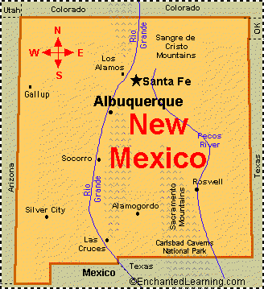
Cotton producers in this region have traditionally been afforded luxury consumption of water, irrigating three to seven acre-feet of water per growing season. Due to drought conditions on the upper Rio Grande, irrigation will be restricted to one acre-foot in the 2003 growing season. To remain successful, producers need to quickly adapt to this situation. One possible adaptation is to switch to the production of organic cotton. Organic production can reduce expenses, improve cotton price and marketing opportunities, and reduce the environmental impact associated with the application of broad-spectrum insecticides. This requires alternate approaches to the control of insect pests.

Some 35 years ago, New Mexico and West Texas had no primary pest insect problems in cotton production. The pink bollworm (Pectinophora gossypiella) was present, but the cold winter temperatures in the area kept the population low. As winter temperatures became warmer, pink bollworm became an economic problem along with the introduction of boll weevils (Anthonomus grandis) approximately 10 years ago. Both boll weevils and pink bollworms required widespread insecticide applications.

Insecticide resistance is the number one insect control problem in the world. Billions of dollars are used in insecticides and pesticides. This not only causes economic problems, but serious environmental problems, too. Cotton is the largest user of insecticides in the United States.

One solution to this problem is to use biological control on cotton crops. Biological control is an action taken by people using what are called "natural enemies" or "antagonistic organisms." These may be predators, parasites, parasitoids, pathogens, or competitors of the pest that is to be controlled. In 2002, a region-wide effort was made to eradicate pink bollworms. This lead to a drastic reduction of pink bollworm populations, which in turn allows remaining pests to be controlled by the beneficial complex that exists in the growing region. Alfalfa remains a primary source of beneficial insects in New Mexico. Some strategies include allowing beneficials already present to control pests, encouraging migration of beneficials (for example, by mowing adjacent alfalfa), or releasing beneficials into areas of infestation.

These techniques require accurate identification of species and developmental stage of insect pests. In addition, the condition and stage of growth in the cotton plants must be considered. The parameters affecting the appropriate use of biological controls may not be well understood by producers. Thus, cotton produces can efficiently manage their crops and maximize profits by using the DSS for advice on biological pest control.

In the long term, the CDMS is intended to provide the DSS with access to the data needed to advise cotton growers. In the short term, the CDMS will support research efforts related to insect pest controls and cotton research. Data stored by the CDMS will be collected in the field by growers and researchers, taken from satellite images, derived from weather reports, and collected in the laboratory. Since the growers, researchers, and laboratory technicians may be geographically dispersed, the CDMS must allow users to enter and receive data remotely. Therefore, an internet-based system is envisioned.

The hierarchy of the data can be described in the following manner:
- Projects can have one-to-many seasons.
- Seasons can have one-to-many treatments.
- Treatments can have one-to-many fields.
- Field can have one-to-many plots.
- Plots can have one-to-many reps.
- Reps have many plants.
Figure 1 below is an example of the layout of a cotton field. The field is represented by the large rectangle. This field contains three plots. Plot 1 has 4 reps, each with 2 treatments. The treatments are irrigation/fertilizer. The numbers 4, 5, and 6 represent the number of irrigations. The high and low represent the amount of fertilizer used. The highlighted square would be referenced as “Field A, Plot 1, Rep 1, 4 High.”
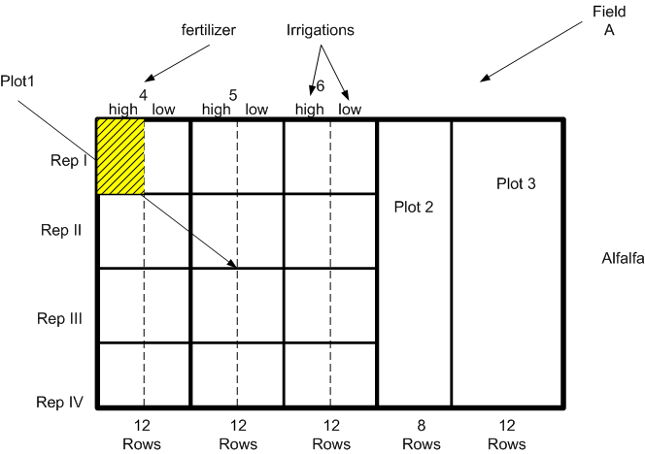
Figure 1 Field Layout

Product Perspective
CDMS will be a tool to manage information related to the prediction and analysis of cotton growth. The main uses of the system include the following.
- The system will act as a repository of insect data for cotton, including insect images, classifications, features, and population histories.
- The system will act as a repository for cotton growth data in the Upper Rio Grande Valley.
- The system will provide data to a DSS for advising growers.
- The system will provide electronic access to data for growers and researchers.

The CDMS will need to interact with both new and existing systems. Software tools such as GIS will provide access to geographic and satellite imaging data. The COTMAN software will generate Cotton yield predictions. Weather data will be obtained from the National Weather Service web site or university weather stations located throughout the state (http://www.weather.nmsu.edu). Insect classification and population data will be obtained from the image analysis software currently under development at NMSU.

Product Features
The use case diagram shown in Figure 2 describes the main features of the CDMS. Briefly, the system must interact with external programs such as COTMAN, and it must store data and provide query access to the data.

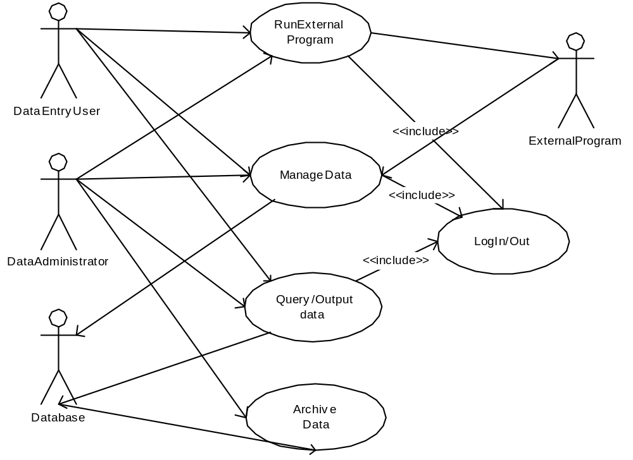
Figure 2 Use Case Diagram

Use Cases
Use cases are descriptions of interactions that users have with the system. They define the boundaries of the system as well as the sequence of operations needed to accomplish a task. The use case description contains descriptions of actors and use cases. An actor is any entity outside of the system that the system needs in order to complete its tasks. For example, the user, the database, and the external programs are actors. Use cases are abstractions of the important operations that provide value to a user. Use cases contain scenarios, which describe in detail the sequence of operations.

In the descriptions below, system refers to CDMS.

Actors are described in Table 4 Actors in section 2.3. Table 5 External Programs describes the External Programs.

- Log In/Out
Description: To prevent unauthorized access to the system, users must be authenticated. Users will gain access to the system by logging in. Each user will have a unique userid. Each user will have a password that is verified prior to giving access to the user.
Actors: Data administrator, Data Entry User, and Database
Used by: All other use cases

  - Log In
Description: The user would like to log in to the system. The user must provide a userid and a password. The system will verify the information with the database and determine the corresponding access to the system.
Preconditions: The user’s account has been created and is a member of at least one group.
The application is running and the initial screen has been displayed.
Postconditions: The user is logged into the system.
Steps:
    - System displays log in dialog box.
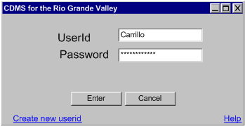
    - User enters userid and password. The system blocks the password as the user types.
    - The user selects Enter. ALT 1.
    - The system encrypts the password and submits a query to the database.
    - The database finds the password for the user, encrypts the password, and returns it. If no match is found, a null password is returned.
    - The system compares password from the database with the encrypted password. Entries match. (Note that no password matches the null password returned if the database did not find this user.) ALT 2.
    - The system checks to see if the user is a member of more than one group
    - The user is a member of only one group. ALT 3
    - The system displays the main menu.
    - End of use case.

      - User selects cancel.
        - End of use case.

      - Comparison fails.
        - The system displays error message like the one shown below with information on why login failed.
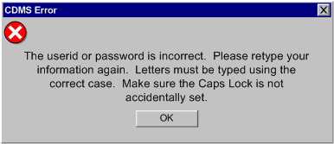

        - The system stores a record of the failed attempt including the name, the date, and the time of the failure. (This data may be used to monitor intrusions for web interface security.)
        - Use case continues at step 1.

      - The user is a member of more than one group
        - The system prompts the user to select what group to use for the session.
        - The system set the group selected as the user’s primary group for the session.
        - Use case continues at step 9.

  - Log Out
Description: The user would like to log out from the system.
Actors: Data administrator, Data Entry User, and Database
Preconditions: User is currently logged into system (Refer to Use Case 1: Scenario 1.)
Postconditions: User has been logged out of system.
Steps:
    - User selects option to log out of system by selecting the logout option on the menu (or by using the keyboard shortcut). ALT 1
    - The system checks the saved status of data.
    - All data has been saved. ALT 2
    - The system logs the user out of the system.
    - System displays the initial screen.
    - End of use case.

      - User cancels the action.
        - End of use case.

      - The system displays message alerting the user that some data has not been saved.
        - System displays message requesting Save and Exit, Exit without saving, cancel, as shown below.
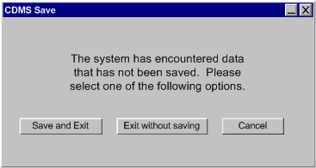
        - User confirms that he/she would like to Save and Exit system. ALT 3
        - System saves data and continues with step 4.

      - User select to exit without saving.
        - The system discards local, unsaved data and continues with step 4.

- Run External Program
Description: User selects the option to run an external program. The external programs are listed in Table 5. The details of running these programs have been omitted.
Actors: Data entry user, data administrator, external program and database.
Preconditions: User has successfully logged into the system (Refer to Scenario 1:).
Postconditions: System displays output from external program.

  - Run GIS program
Steps:
    - The user selects to run one of the programs Table 5.
    - The system asks for input for the program.
    - The user provides input.
    - The external software executes.
    - The system displays the output.
    - End of Use Case.

  - Run Image Processing Program
Description: The user would like to manage image data. This will be done by using the image processing system being developed at NMSU.
Actors: DBMS, Data Entry User, Data Administrator User
Steps:
    - The user selects to Manage Image Data
    - The system displays the external program menu.
    - The user selects to run the image-processing program.
    - The system runs the image processing program. (ALT 1)
    - The image-processing program returns the filename of the formatted output file.
    - The system reads the formatted file provide by the image processing system. (ALT 2)
    - The system sends a sequence of statements to update the database.
    - The database system updates the database and marks the data with the users group and owner. (ALT 3)
    - The system confirms the update and displays the new data to the user.
    - End of use case.

      - The system cannot run external program.
        - The system displays an error message to user, writes the error to the logfile.
        - Use case continues with step 2.

      - The system cannot parse the file.
        - The system displays an error message to user, writes the error to the logfile.
        - The system provides the option to retry the parsing or to cancel.
        - The user selects to retry the parsing (ALT 4)
        - Use case continues with step 6.

      - The database fails to update the data.
        - The system displays error message indicating the data cannot be updated.
        - The system gives option to save the data locally or abort the update.
        - User selects to save locally. (ALT 5)
        - The system saves the data in a local file.
        - End of use case.

      - The user selects the save as option
        - The system prompts the user for the filename and directory information of the file.
        - The system saves the data into the selected directory.
        - End of use case.

      - User selects to cancel operation.
        - System returns to manage options.
        - End of use case.

- Manage Data
This use case covers the entry, editing, and deletion of data from the database. Data entry users may only access data entered by someone in their access group. Data administrators can manage data for the entire system.

Actors: data administrator, data entry user, database
Preconditions: The user has successfully logged in (Refer to Use Case 1:).
Postconditions: Selected data has been modified.
  - Edit Data
Description: The user wishes to edit data from the database or from a loaded local file.
Steps:
    - The user selects the Edit Data option from the menu.
    - The system displays a list of data sets.
    - The user selects a dataset.
    - The system submits a query to the database to determine the datasets to which this user has access.
    - The database returns the dataset identifiers. (The data set does not necessarily correspond to a table in the database. In general, it may be any table created by a query to the database. Users are given access to datasets based on the user’s group identifier.)
    - The system prompts the user for the data set to edit.
    - The user selects a dataset.
    - The system submits a query to the database.
    - The database returns the dataset.
    - The system displays the dataset in “Excel-like” format (Refer to Figure 3 Grid Display.)
    - The user deletes, modifies, or adds data to the table.
    - The system visually indicates the fields in which changes have been made, and visually indicates that the table has been modified.
    - The user selects the Save option. (ALT 1), (ALT 5)
    - The system checks the data by performing integrity checks. The data passes the checks. (ALT 2)
    - The system submits a sequence of update queries to the database.
    - The database system updates the database. (ALT 3)
    - The system confirms the update and displays the updated data to the user.
    - End of use case.

      - User selects cancel. (ALT 5)
        - End of use case.

      - Data integrity checks fail.
        - The system reports the error to the user in an error dialog.
        - The system continues with step 8.

      - The database fails to update the data.
        - The system displays error message indicating the data cannot be updated.
        - The system gives option to save the data locally or abort the update.
        - User selects to save locally. (ALT 4)
        - The system saves the data in a local file.
        - End of use case.

      - User selects abort update.
        - The system writes the error to the logfile.
        - End of use case.

      - User selects save as option.
        - The system prompts the user for the filename and directory information of the file.
        - The system saves the data into the selected directory.
        - End of use case.

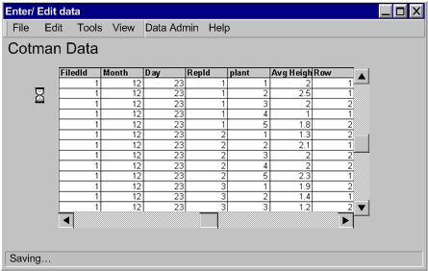
Figure 3 Grid Display

  - Import Data
Description: The user wants to enter data into the database in a “batch” mode. This is the case when data has been collected in the field on a laptop or handheld device or if data is obtained from some other source such as an external program. The data can be agronomic data, insect sampling data, or GIS data. Agronomic data includes weather data, field sampling data used for COTMAN, and IR images taken of the field. Insect sampling data includes image files of the insects and data from the image processing system. GIS data includes raster images and vector overlay maps.
Actors: Data Entry User, Database, External Program
Steps:
    - The user selects the import menu option.
    - The system displays the import menu. Each type of import is listed, including import from each external program, import from external system, and import from handheld device.
    - User selects an import type.
    - The system collects the data from the external program, system, or handheld. (ALT 1)
    - The system checks the data by performing integrity checks. The data passes the checks. (ALT 2)
    - The system submits a sequence of update queries to the database.
    - The database system updates the database. (ALT 3)
    - The system confirms the update and displays the number of records that were transferred. The system will visually indicate to the user that the transfer is complete.
    - End of use case.

      - Data collection fails.
        - The system displays an error message indicating that data collection has failed.
        - End of use case.

      - Data integrity checks fail.
        - The system reports the error to the user in an error dialog.
        - The system displays the data and continues with Scenario 1 step 8.

      - The database fails to update the data.
        - The system displays error message indicating the data cannot be updated.
        - The system gives option to save the data locally or abort the update.
        - User selects to save locally. (ALT 4) (ALT 5)
        - The system saves the data in a local file.
        - End of use case.
.
      - User selects abort update.
        - End of use case.

      - User selects save as option.
        - The system prompts the user for the filename and directory information of the file.
        - The system saves the data into the selected directory.
        - End of use case.

  - Create Project
Description: The user wishes to create a new project to enter data directly from the keyboard to the database.
Steps:
    - The user selects to create a new project.
    - The system prompts the user for the project name, and initial data such as fields, and seasons.
    - The system creates a new project. (ALT 1)
    - The system displays the options to import or enter data for the project
    - End of use case.
      - The system cannot create the project.
        - The system reports the error to the user in an error dialog box with options to retry or cancel.
        - The user selects to retry to create the project. (ALT 2)
        - Use case continues with step 3.

      - User selects cancel.
        - End of use case.

  - Enter Data
Description: The user wishes to enter data directly from the keyboard to the database.
Steps:
    - The user selects Enter Data.
    - The system prompt the user to select the project the data will be associated to.
    - The user selects the project
    - The system retrieves the data associated with the project selected.
    - They system provides the corresponding forms for the user to enter the data.
    - The user enters the new data for the tables.
    - The user selects the Save option. (ALT 1), (ALT 5)
    - The system checks the data by performing integrity checks. The data passes the checks. (ALT 2)
    - The system submits a sequence of update queries to the database.
    - The database system updates the database and marks the data with the users group and owner. (ALT 3)
    - The system confirms the update and displays the new data to the user.
    - End of use case.

      - User selects cancel. (ALT 5)
        - End of use case.

      - Data integrity checks fail.
        - The system reports the error to the user in an error dialog.
        - The system continues with step 8.

      - The database fails to update the data.
        - The system displays error message indicating the data cannot be updated.
        - The system gives option to save the data locally or abort the update.
        - User selects to save locally. (ALT 4)
        - The system saves the data in a local file.
        - End of use case.

      - User selects abort update.
        - The system writes the error to the logfile.
        - End of use case.

      - User selects save as option.
        - The system prompts the user for the filename and directory information of the file.
        - The system saves the data into the selected directory.
        - End of use case.

- Query/Output Data
Description: System outputs data based on user’s query.
Actors: User, DBMS
Preconditions: Data has been stored in a database and images have been stored in hard drive or other external storage devices. User has successfully logged in our system (Refer to Use Case 1:).
Postconditions: Desired output is displayed on the screen.
  - Query Data
    - User selects to go to the Query window and query the database.
    - User enters a query, which can be either of the two following formats:
- User enters a list of keywords to provide information.
- User chooses the advanced search by completing a list of information provided by the interface.
    - User selects the search option. ALT 1
    - System reads and processes user’s query.
    - System sends the processed query to DBMS. (See the remaining scenarios.)
    - DBMS takes the processed query as input.
    - DBMS begins searching the database. ALT 2
    - DBMS returns the results. ALT 3
    - System displays output options. (screen, report, external program file)
    - User selects result to display on the screen. ALT 4
    - Depending on the type of data being searched, the display will contain one of the following elements:
- An image and links.
- Image data that can be a map, insect image or a GIS vector layer.
- A table and links.
    - End of use case.

      - User selects to cancel process.
        - End of use case.

      - Search failed.
        - System displays an error message and option to retry or cancel.
        - User selects option to retry search.
        - Return to step 7. ALT 1

      - No Results found.
        - System displays a message indicating that no results found.
        - End of use case.

      - User selects to print a Report
        - System prompts for report option.
        - System print previews report and displays option to print, save or cancel.
        - User selects print option ALT 5
        - System sends report to printer.
        - Endo of use case.

      - User selects save option. ALT 1
        - System prompts for report name and location to save.
        - System saves report and returns to query option.
        - End of use case

- Archive Data
Description: The Data Administrator wants to archive data for off-site storage or to preserve data, or the Data Administrator wants to restore data from an archive. The administrator may remove or add data from the database during this operation.
Actors: Data Administrator, DBMS

  - Archive Database
Description: The user would like to archive files in the database.
Preconditions: The Data Administrator has successfully logged into the system.
Postconditions: Data has been written to an archive file and possibly has been removed from the database.
Steps:
    - The user submits a query to the system to selects the data to archive in the database. User is Data Administrator. ALT 3
    - The system submits a query to the database.
    - The database returns the dataset.
    - The user provides a file name for the output archive file.
    - The system performs archive process.
    - The system displays confirmation message indicating that archive was successful. ALT 1
    - The system prompts the user to remove archived data.
    - The user affirms. ALT 2.
    - The system removes the archived data.
    - End of use case.

      - System archive failed.
        - System displays error message indicating archive failure.
        - System displays option to retry or cancel operation.
        - User selects option to retry archive. ALT 2
        - Return to step 2.

      - User selects to cancel operation.
        - System returns to manage options.
        - End of use case.

      - User is a data entry user and does not have permissions to archive database.
        - System displays error message indicating the data cannot be archived due to user privileges.
        - End of use case.

  - Restore from Archive
Description: The user would like to restore data from an archive file.
Preconditions: The Data Administrator has successfully logged into the system. An archive file has been created previously.
Postconditions: Data has been written to the database.
Steps:
    - The user selects Restore from Archive.
    - The system prompts for the file and path of an archive.
    - The user selects an archive file.
    - The system restores data from the archive. No primary keys in the database match primary keys from the archive. ALT 1.
    - End of use case.

      - Primary Keys Match.
        - The system detects records in the database matching primary keys in the archive.
        - The system prompts the user to replace existing data, keep existing data, or cancel the restore.
        - The user selects replace existing data. ALT 2, ALT 3.
        - The system replaces existing data in the database with data from the archive.
        - End of use case.

      - User selects to cancel operation.
        - End of use case.

      - User selects to keep existing data.
        - The system continues to read the archive file storing data into the database only when the primary key of the archive data does not match any primary key in the database.
        - End of use case.

User Characteristics
There are two types of users for this system, data entry user and data administrator. Both users are familiar with common software applications such as word processors and spreadsheets. Thus, these users are comfortable with operations involving keyboard and mouse actions.

Actor | Description
Data Entry User | This user can access any data as read only. The user can add, modify, and delete his /her data only.
Data Administrator | This user inherits all the functionality of the data entry user with additional privileges to input, modify, view, and delete anyone’s data.
Database | This the relational database that will store all the information entered into the DBMS. Refer to
External Programs | External programs refer to a series of programs that interact with our system to provide data input or output. These programs include COTMAN, GIS software, MatLab, spreadsheet program, and Dr. Drake’s image processing system. Refer to Table 5 External Programs
Table 4 Actors

COTMAN | is a program CDMS interfaces to generate crop growth patterns and predict crop yields.
GIS Software | is a system that can manage GIS documents. These GIS documents are called coverages. Coverage is a table linked to graphic information. The graphic information accepted in coverage must be lines, points, polygons and images; each one is linked to a unique record in the table.
MatLab | is a software that analyzes data and generates diagrams to show the relationship between them.
Excel | Spreadsheet program provides input in table form into our system.
Image Processing Program | will handle all image segmentation functions, what will go to the database will be sets of related images.
Table 5 External Programs

General Constraints
The following constraints are recognized.
- The system is intended to run on a Windows based PC/laptop. It will have an interface that conforms to standard Windows applications.
- The database management system will be Oracle. The Oracle system will run on a server, and the CDMS will access the server via the Internet. The server side application will support multiple simultaneous users.
- The System will provide an output format that can be imported into a Microsoft Excel spreadsheet. An example of such a format is a CSV file.
- The system will be completed by December 2003.
- The system will not be accessible to unauthorized users.
- Data and access to the system will not be provided to unauthorized users. Thus, some security mechanism must be in place to prevent unauthorized access to the data when it is transmitted over the network. Refer to Appendix E Security Protocol
- Public/Private key security protocol will be used.
- The key transport protocol will be Needham-Schroeder Protocol [12]
- Data will be encrypted for transmission integrity.
- The clients may change the database from Oracle to some other commercial product. The design should minimize the impact of this change.

Assumptions and Dependencies
The following assumptions are made:
- A windows compatible version of all the External Programs will be made available.
- Examples of data sets will be made available prior to November 2003.

Specific Requirements
This section contains the specifications for external and internal software interfaces.

External Interface Requirements
This section describes all the specific requirements of the CDMS. This section is divided into external interface requirements, behavioral requirements, non-behavioral requirements and other requirements.

General Characteristics
- The system shall have a graphical user interface (GUI) constructed from standard, Microsoft-like interface elements such as windows, menus, buttons, pull-down lists, and text boxes.
- The system’s user interface shall accept user input from the keyboard and from the mouse. Mouse actions shall follow the Microsoft standard: single-click for selection and double-click for selection and action.
- The system shall have scroll bars for windows displaying a variable amount of text
- The system shall support standard Windows keyboard shortcut methods for accessing menu items (e.g., ALT + letter).
- The menu shall be placed at the top of the DBMS application window.
- The system shall present a confirmation window to the user with the options to continue or cancel the operation when responding to a user selection that may modify the contents of the database.
- The system shall provide auto completion of words as the user is typing. Auto completion will suggest the most likely word completion as a user is typing text. Pressing the TAB key accepts the suggested word. Examples of auto completion include suggesting a uniquely matching file name, suggesting a uniquely matching database attribute name, or suggesting a uniquely matching database entry such as insect name or genus.

Menu Options
- The GUI shall display a menu bar with the menu and submenu elements listed in Table 6 .

File | Edit | Tools | View | Data Admin | Help
Open  Close  New Season  New Field  Logout  Save  Print  Exit | Delete  Copy  Cut  Paste  Import Data  Download Data  Enter/Edit Data  Default Group | Cotman  Matlab  GIS  Image Processing  Weather  Database Query | Report | Backup Data  Archive Data  Restore Data | About CDMS
Table 6 Menu Options

Display Screen and Windows
This section describes the primary windows and window characteristics in the user interface.

Common Screens and Windows
- The user interface layout shall contain a window with the elements shown in Figure 2.
- The main window of the system shall have a title bar containing the title “CDMS Main” and the version number.
- The title bar of the main window shall contain minimize, maximize, and close button controls on the right side of the bar.
- The main window of the application interface shall contain a menu. Menus are described in Section 3.1.2.
- The min window of the application interface shall contain a status bar. The status bar shall display brief messages to the user to indicate the state of the actions.

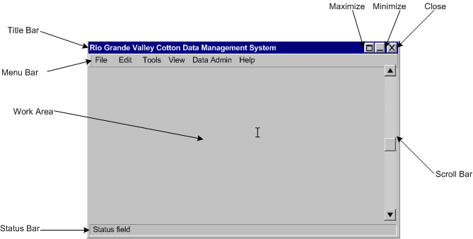
Figure 4 User Interface Layout

Data Entry Users
- The system shall not display the Data Admin menu option when user is a data entry user.

Data Administrators
- The system shall display the Data Admin menu option when user is a data administrator user.

Hardware Interfaces
There are no hardware-specific requirements for this system.

Software Interfaces
- The client software shall execute on a personal computer running on Windows OS.
- The data shall be stored in an Oracle database [12]. The version of Oracle shall be Oracle9i.
- The system shall interface with COTMAN program. The system must assist the execution of Cotman and provide data to Cotman.
- The system shall interface with MatLab program.
- The system shall interface with the Excel spreadsheet program.
- The system shall interface with the image processing software currently under development at NMSU.
- The system shall interface with GIS software. The DBMS shall facilitate the import of land use information (maps, images, and other GIS vector layers), weather data, soil moisture, soil type, and irrigation, infrared reflections from crops, fertilizer pesticide application data, insect image files, density data, and GPS location data.
- The DBMS shall include a user an interface and interfaces to the sources of data, including a program that classifies and counts insects.
- The DBMS shall provide an application program interface (API) for use by the decision support system.

Communications Interfaces
The system must support users collecting data in the fields. These users may be running a copy of the system on a laptop or running a data acquisition suite on a PDA. Data entered on these devices while not connected to the network must be unloadable to the system when the users connect these devices to the network.

- Access to the Oracle database shall be provided via a set of Web Services [13]. These web services shall be made available via the Internet and shall run on the database server.
- The user interface shall run as a Web Service client application and access the database via Web Services.
- The system shall provide the capability to import and download data to a PDA hand held device or a laptop.

Behavioral Requirements

Same Class of User
- The system shall have two kinds of users: data entry users and data administrators.
- The system shall allow data entry user and the data administrator to:
- Query the database via the DBMS.
- Input data into the database via the DBMS.
- Each user shall be assigned to one or more groups. The user’s primary group shall default to the first group.
- The system shall provide an interface for setting the users primary group. Each user shall be able to set his/her primary group.
- The system shall allow a data administrator to perform any of the functions related to the collection of data.

Data Entry User
- The system shall allow data entry users to add, modify and delete data that belongs to a group of which this user is a member.
- When a data entry user enters new data to the database, the system shall mark this data as belonging to the data entry user’s primary group.

Data Administrator
- The system shall allow the data administrator to add, delete or modify data regardless of the group owning the data.
- The system shall provide the data administrator with the capability to backup data in the database.
- The system shall provide the data administrator the capability to restore data from a backup. Data restoration shall overwrite data with matching keys in the database tables and add data to the database if no records with matching keys are found.
- The system shall provide the data administrator with the capability to archive data from the database. Archiving data means writing data to file or device and removing the data from the database.
- The system shall provide the data administrator the capability to restore data from an archive.

Related Real-world Objects
Objects are real-world entities with either physical or conceptual counterparts in the real word. Conceptual objects are presented in the database relational model in the Appendices. The objects for the system described in this section are External Programs, Fields, and Plants.

External Programs
- The system shall provide a file that can be imported into another system. The system shall be able to read a file produced by another system. This will allow a user running the system on a laptop in the field to import data to a central server.
- The system shall accept files as input, including image files, GIS files, spreadsheet files, and MatLab files, image processing files.
- All image files shall be identified with the following information: date, time, location altitude, equipment, color (for IR processing), temperature, and weather conditions.
- The system shall use GPS coordinates to specify location.

Fields
- The DBMS shall identify cotton fields by owner and field number.

Season
- The system shall provide a structure that defines the data on a field.
- The system shall be capable to contain information for several seasons at a time.
- The system shall be able to relate insects to location, time, and means of capture.
- The system shall keep track of seasonal data, season in the upper Rio Grande Valley area. The season encapsulates the data that is associated with the field and data for a particular season.

Plants
- The system shall store data that describe a particular plant location, plant type, and plant growth. The data is described in Appendix C Relational Database.

Insects
- The system shall provide a structure that defines insect images.
- The system shall provide the capabilities to classify insects.
- The system shall keep track of insect populations.
- The system shall keep track of insect properties.

Stimulus

Login
- On startup, the system shall display the login dialog box.
- The system shall log a user in to the system upon userid and password authentication
- The system shall check if the user is a member of more than one user group and prompt the user to select a group for the session.
- The system shall display an error message indicating failed login if either the userid or password is invalid.
- The system shall log unsuccessful login attempts, in the system log file.

Menu Item Selected

File
- When File/Open is selected, a file selection dialog box shall be opened allowing the user to select a file. This dialog box should be similar to other Microsoft application file selection dialogs. Refer to Figure 5 below

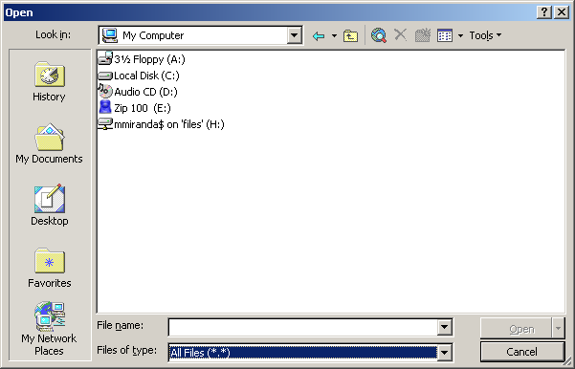
Figure 5 File Selection
- When File/Close is selected, the system will terminate the process the user is working on.
- When File/New season is selected, a dialog box requesting the name that will be associated with the new season. This dialog box should be similar to other Microsoft application new file dialogs.
- When File/New season is selected, the system shall create a new project with the name given by the user and display the main menu to the user.
- When File/New Field is selected, a file selection box shall be open allowing the user to select what season file the new field is associated with. This dialog box should be similar to other Microsoft application file selection file dialogs.
- The system shall create a new project with the name given by the user and display the main menu to the user
- When File/Save is selected, a file selection dialog box shall be opened allowing the user to select a file.
- When File/Save is selected and the user selects a file, the current data shall be written to the file.
- When File/logout is selected, the system shall close any open windows and return to the login dialog box.
- When File/Exit is selected, the system shall close any open windows and return to Windows desktop.

Edit
- When Edit/Import Data is selected, the system shall open a file selection dialog box displaying options from where the data will be imported.
- When the file to be imported has been selected, the system shall check the integrity of the data and provide options to the user to cancel, save new data only, or overwrite new data.
- When Edit/Import Data is selected, the system shall prompt for identification information for the data being imported.
- When Edit/Import Data is selected, the system shall open a file selection dialog box. The system shall display an error if file not found.
- When Edit/Import Data is selected, the system shall mark the data with the groupid of the user.
- When Edit/Import Data is selected, the system shall store the data unless there is a conflict. The system shall prompt the user he/she would like to override the conflict.
- The system shall allow the override the conflict if the current user is in the existing data’s group.
- The system shall reject the override the conflict if the current user is not in the existing data’s group. The system shall return to the previous sate.
- The system shall allow the override the conflict if the current user is data admin. The system shall update only new data.
- When Edit/Import Data is selected, the system shall display a confirmation message when data has been imported into the database.
- When Edit/Delete is selected, currently selected text is deleted.
- The system shall display a confirmation message when a change has been made to the database.
- When Edit/Copy is selected, the system shall copy the selected text area to the temporary clipboard and wait for user’s next command.
- When Edit/Cut is selected, the system shall remove the selected text area from its current place and copy it to the temporary clipboard and wait for user’s next command.
- When Edit/Paste is selected, the system shall copy what is in the temporary clipboard into the position of the cursor.
- When Edit/Enter/Edit Data is selected, the system shall provide data entry user and the data administrator an interface for the import of land use information (maps, images, and other GIS vector layers), weather data, soil moisture, soil type, irrigation, and infrared reflections from crops, fertilizer pesticide application data, insect image files, density data, and GPS location data.
- When Edit/Default Group is selected, the system shall provide data entry user and the data administrator a list of groups to which that user is assigned. The user shall be able to select any of these groups as the default group. Once selected, all data edits will be made as a member of this group.

Tools
- The system shall display the run external program menu when the user selects the “Tools” menu option.
- When the user selects on the button to run COTMAN, GIS software, Excel, MatLab, or IPS, the system shall prompt the user for inputs to run that program.
- The system shall input all required data to an external program when the user selects the “Run External Program” option for the specified External Program.

View
- When View is selected, a selection dialog box shall be opened allowing the user to select a view created by the data admin.
- The system shall provide a function for the data admin to create a view of tables.

Report
- When View/Report is selected, the system shall provide options for the types of reports available to the user. Once the user makes the selection, the system shall generate a preview with the content of the report selected. The user shall not be able to edit this file in this display.
- The system shall provide and option to print, save, or export reports.

Data Admin
- When Data Admin/Backup Data is selected, the system shall prompt for full or incremental backup.
- Full backup, copies the entire database.
- Incremental Backup, copies changes since last full backup.
- The system shall prompt for the directory to write to.
- The system shall display a confirmation message when the system has been backed up.
- When the Data Admin/Archive Data is selected, the system shall prompt the user for dates, and data to be archived.
- The system shall mark the data as archived, move the data to a different location, and remove it from the database
- When the Data Admin/Restore Data is selected, the system shall prompt for specific dates, data identification, and/or directory of the data that will be restored.
- The system shall search the directory for the specified data and restore the data to the system and remove it from the archive.
- When the Data Admin/Logfile is selected, the system shall display options to the data admin to save, edit, print, or export the logfile.

Help
- When the user selects the help option, the system shall display a window similar to the standard Microsoft help window, with and index of topics specific to the system.

Related Features
- The system shall be able to generate files for use with the same Database, Matlab, ERDOS, and a Spreadsheet program.

Functional
Functional requirements should define the fundamental actions that must take place in the software in accepting and processing the inputs and in processing and generating the outputs.

Queries
- When Tools/Database Query is selected, the system shall open the query dialog box. (See Figure 6)
- The system shall provide a set of standard predefined SQL queries to the user. Refer to Appendix F Predefined Queries.
- When a predefined SQL query is selected, the system shall open a dialog to fill in the parameters of the predefined query.
- When SQL commands are entered in the query dialog box, the system shall submit the SQL to the DBMS and display the result to the user.
- When a query is entered in the query dialog box and the query is not SQL, the system shall translate the query into appropriate SQL. This feature should allow users to enter “google-like” queries in natural language.
- When a new query is entered, the system shall provide the capability to save the query and display it as a predefined query. New queries may be parameterized, allowing users to fill in data for a query. For example, a new query may allow a date field to be a parameter, allowing a user to reuse a query while changing the date.
- The system shall provide a filter function that will narrow the query results.
- The system shall allow for advanced query options to match case, wildcards, and all word forms. (i.e. lady_bug, lady bug, ladybug, Ladybug)

Query Results
- The results of queries shall be displayed on the window work area in tabular form.
- The system shall provide methods to create new files with the results from queries. These files may be ASCII text in tabular form or CSV format that can be imported by Microsoft Excel.
- The system shall be able to produce XY plots, scatter graphs, and bar charts of data. XY plots shall plot columns against columns or rows against rows.
- The system shall provide standard statistical operations including sample size, sum, average or mean, median, max, min, range (max- min), mode (most common value), standard deviation, and variance for data selected by the user.

File Relations
- The system shall generate a log file of all transactions.
- The system shall log the import and failed login attempts in a log file.
- The system shall log all database update errors.

Export/Download
- The system shall allow a user to export data from the database to an external data store.
- The system shall provide a function to export data to a CSV file that can be imported to Microsoft Excel.

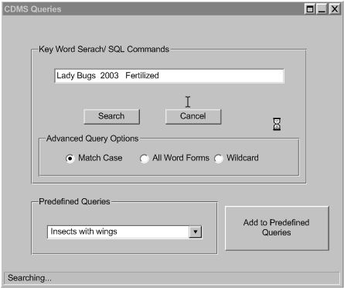
Figure 6 Query Dialog Box

Non-behavioral Requirements

Performance Requirements

Qualitative Requirements
No qualitative requirements have been identified.

Availability
- Access to central server shall be provided at all times while the network is operating.

Security
- The system (server) shall restrict access to unauthorized users by using userid and passwords.
- The system shall encrypt the passwords in the DBMS.
- The system shall use public/private key encryption.
- The system shall use the Needham-Schroeder key transport protocol.

Maintainability
No maintainability requirements have been identified.

Portability
- The system shall allow for future use of PDA's to collect data from the cotton fields.
- The system shall allow for data collection from more than one laptop.

Design and Implementation Constraints

Other Requirements

Database
- The system shall interface with a DBMS described in Appendix C Relational Database.
- The system shall keep a log of Database operations.
- The system shall store data in a format that can be imported into an Excel spreadsheet. A CSV format may be used for this purpose.

Operations
No Operations requirements have been identified.

Site Adaptation
No site adaptation requirements have been identified

Appendix A Data Flow Diagram

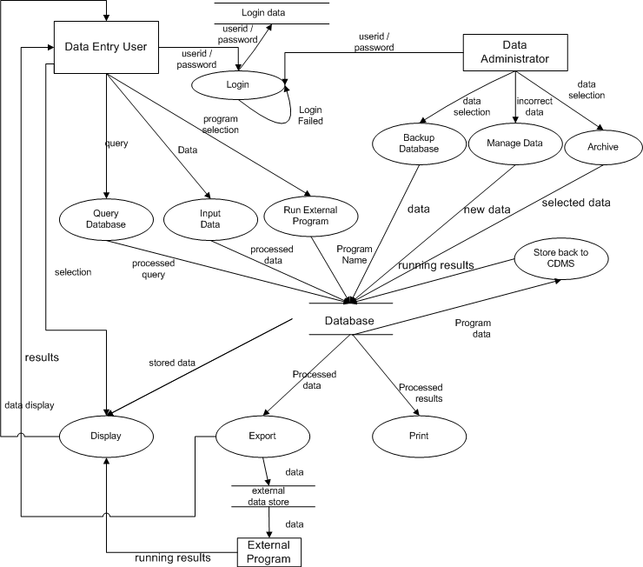
Figure 7 Data Flow Diagram

Appendix B Message Sequence Diagrams

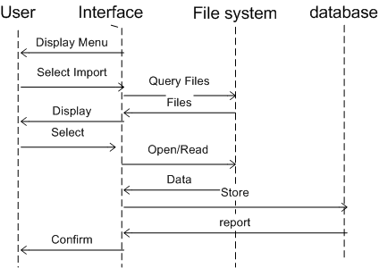
Figure 8 Import Sequence Diagram

Appendix C Relational Database
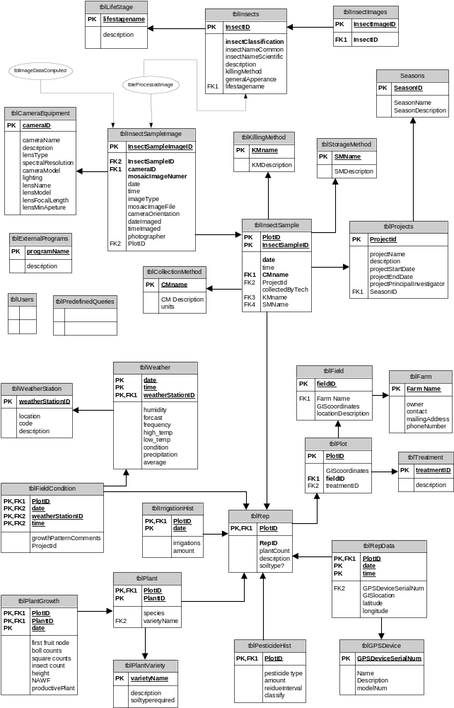
Figure 9 Database Decomposition
The decomposition diagram in this SRS is not complete. The diagram above reflects mainly the tables that will hold the data that the customers intended to query. There are tables not shown that the CDMS will need to store data for the system. Some of these tables are:

Users: This table holds the information that will be used for login procedure (i.e.) password, userid and other fields.

Query: This table holds the predefined queries in Appendix F Predefined Queries and should allow for the addition of more queries.

Log: This table holds the login errors, system errors, and any other information the clients would like to record

In addition to the tables mentioned above, the diagram excludes tables that were not well defined. This information continues to have design issues that should be carefully considered in order to provide the clients with an efficient and accurate database. The ellipse,  , represents tables that have not yet been defined.

Tables

Sample- Collection of insects taken from a rep or field on a particular date.
Sample Image- For a given sample, several images will be produced with different camera orientations (top, bottom, flash, no flash, etc). Each of these images must be uniquely identified and must include a reference to the original sample. These images will be fed into the image process program. The program will return a file with the coordinate information that can generate the processed image. The file will contain original sample name, date imaged, object (insect) outline file location, total insect count, predator count, prey count, classification technique, the individual counts for each type of insect identified in the image, and each individual insect object ID.

Data not yet included in the Database

Yield- total lint produced for the season can be associated with Project, Season, Field, and there must be a yield produced by at each rep.

Chlorophyll- Collected 3 times a week and an average is taken for the week. The design issue is that chlorophyll cannot be included in tblPlantgrowth because the collection frequency is different. One possible solution is to have a field for the week the data was collected in tblPlantgrowth that can be related to a table that only holds chlorophyll data.

Soiltype- The soiltype should be considered when deciding what variety of plants to use in a particular plot/field. This information can either be associated with the plot, rep or field. The problem with this is that the soiltype may not be consistent within an area of land. Some design issues include the replication of unnecessary data. If the soiltype is consistent within the reps, there may be many reps where the data will be duplicated; however there maybe cases when it is inconsistent and needs to be recorded. Refer to Figure 1 Field Layout

Appendix D: Client-Server Architecture

Database Server

User Desktop
PDA

Database
Services
Web Server
DBMS

User web browser

The database server runs the Oracle database software. The Database Services is an application that provides access to the database. This application provides a layer of abstraction between the client applications and the database and is responsible for handling security.

The User Desktop is an application program that utilizes the database services and provides an interface to the user. This interface allows the user to upload data from a PDA and access data through the database services.

An alternate user interface is provided through a web page. A CGI program executes on the web server accessing data through the database services. The server provides a web page (with forms), and the CGI application generates HTML pages dynamically. This interface allows users to access the system without having to install the software that accesses the web services directly. The web server application would be responsible for parsing an uploaded data file and formatting for the web service.

Appendix E Security Protocol

CLIENT →SERVER | (INITIATE * ID* CLIENTpub) | CLIENT sends SERVER a message saying “I want to start a session, here is my public key. Message is clear text.
SERVER →CLIENT | (Token * SERVERpub)_{CLIENTpub} | SERVER sends CLIENT a session token and SERVER’s public key, encrypted with CLIENT’s public key. Only CLIENT can decode the token.
CLIENT →SERVER | (Token * ACCESS * Password)_{SERVERpub} | CLIENT requests access by sending password encrypted so SERVER can read it. The token identifies the session.
SERVER →CLIENT | (Token * Response)_{CLIENTpub} | SERVER tells CLIENT authentication works or does not.
CLIENT →SERVER | (Token * Data)_{SERVERpub} | CLIENT encrypts all data so only SERVER can read it.
SERVER →CLIENT | (Token * Data)_{CLIENTpub} | SERVER encrypts all data so only CLIENT can read it.
CLIENT →SERVER
Table 7 Security Protocol

A token is generated by SERVER to identify a session. Only CLIENT and SERVER ever know the token.
Every communication is started by a session token except the first.
Data can only be decrypted by the receiver.
Initially, CLIENT does not know Server’s public key.
Initially, SERVER does not know Client’s public key.

Appendix F Predefined Queries

- List all projects.
- List all currently active projects.
- List projects by date.
- Show predator/prey ratio for a specified field.
- Show predator/prey ratio for a specified project.
- Show predator/prey ratio for a specified farm or rep.
- Show species for a specified field.
- Show species for a specified project.
- Show species for a specified farm or rep.
- Show data (possibly from a previous query) for a given date or date range.
- Show data (possibly from a previous query) for a given season.
- Show the nodes above white flower and date for a given field, rep, or farm.
- Show the number of nodes, height, and time for a given field, rep, or farm.
- Show the fruiting structure (e.g., 1st position, 2nd position, and absent) for a rep on a given date.

§

